Cloud Services for DevOps - Prerequisites

Problem Statement:

Before diving into cloud-based DevOps practices, we must ensure our local environment is correctly prepared. This means verifying cloud access, configuring credentials, and checking that essential DevOps tools are installed and functional. Setting up this baseline allows all upcoming labs to run smoothly without unexpected blockers.

Tools/Software Versions:

1. Operating System: Windows 11/10 (64-bit) with WSL2 enabled

2. Cloud Account: AWS Account (Active and Verified)

3. AWS CLI: v2.28.21 or Higher

4. Terraform: v1.13.1 or Higher

5. kubectl: v1.33.3 or Higher

6. Docker: v28.3.3 or Higher

7. Python: 3.13+ with pip

8. Git: v2.51.0 or Higher

Hands-on Steps:

Step 1: Verify AWS CLI Installation and Version

We’ll begin by checking if the AWS CLI is installed. The AWS CLI is our bridge between the local machine and cloud resources; without it, we can’t interact programmatically with AWS services.

aws --version

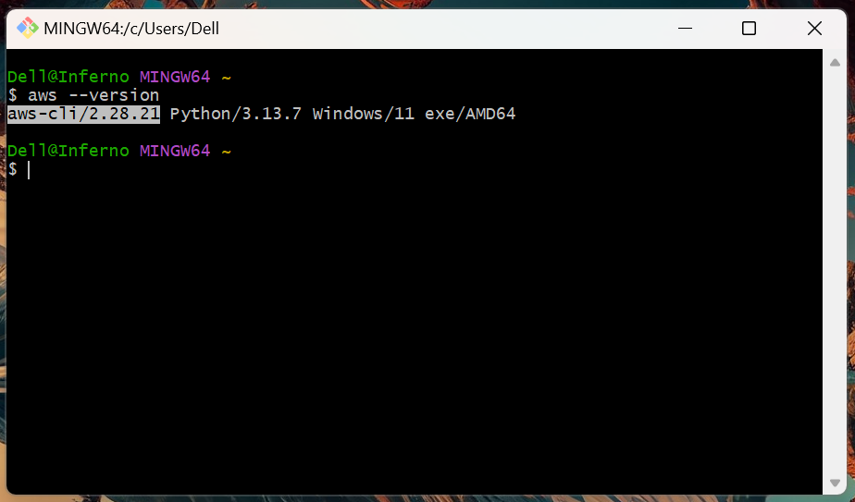

Step 2: Configure AWS Credentials and Default Region

Now that the CLI is available, we must configure it to talk securely with AWS. By entering our credentials and default region, we establish programmatic access for all future operations.

aws configure

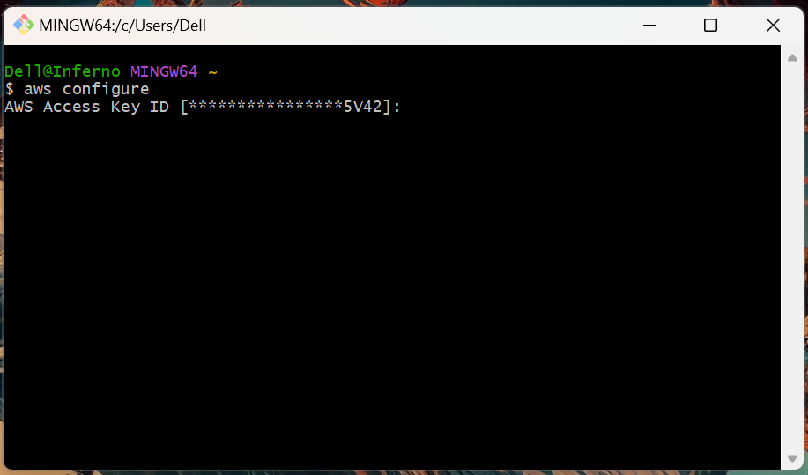

When prompted, enter:

- AWS Access Key ID: your IAM user access key
- AWS Secret Access Key: your IAM user secret key
- Default region name: ap-south-1 or your preferred region
- Default output format: json

To confirm the setup worked, check your identity:

aws sts get-caller-identity

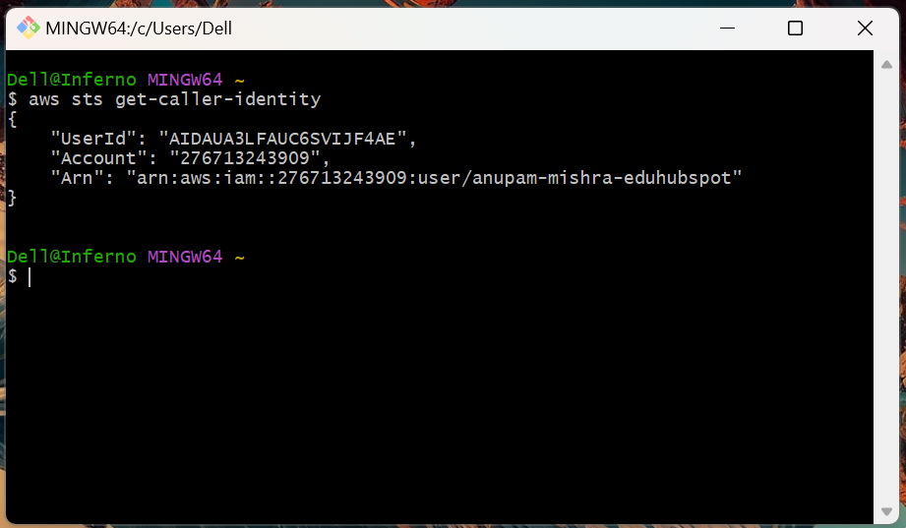

Step 3: Validate Terraform Installation

Terraform lets us define and provision cloud resources as code. Verifying its installation ensures we’ll be able to automate deployments later in the labs.

terraform version

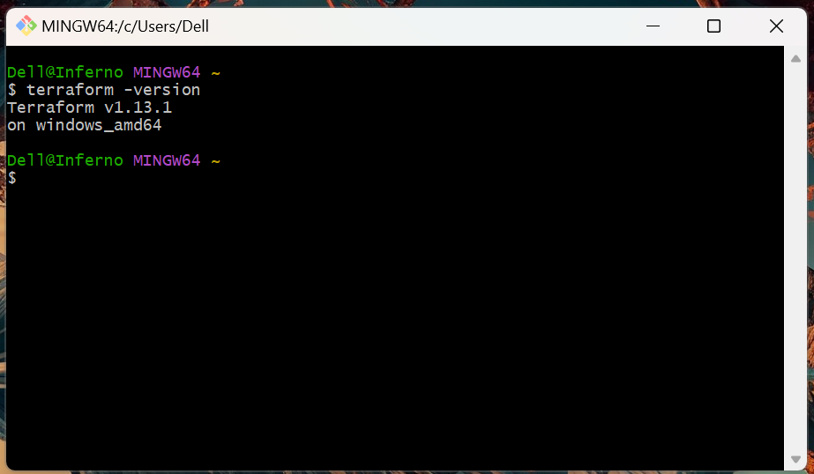

Step 4: Test Docker Engine Functionality

Since much of DevOps revolves around containers, we must confirm Docker is running correctly. Running the hello-world container proves that the engine can build and execute containers successfully.

docker --version

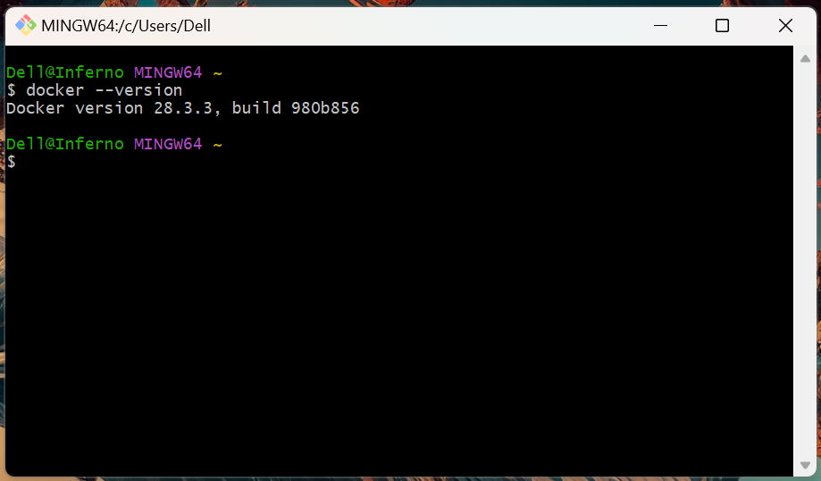

docker run hello-world

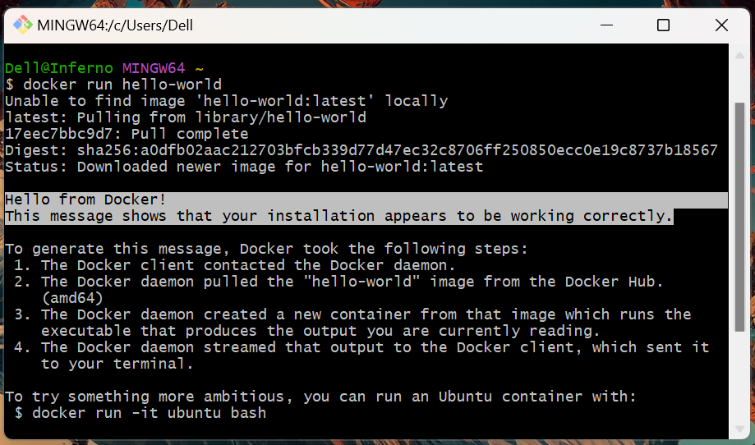

Step 5: Confirm kubectl Client Installation

Kubernetes plays a big role in modern DevOps, so we validate the kubectl CLI is installed. This ensures we’ll be able to control Kubernetes clusters later in the course.

kubectl version --client

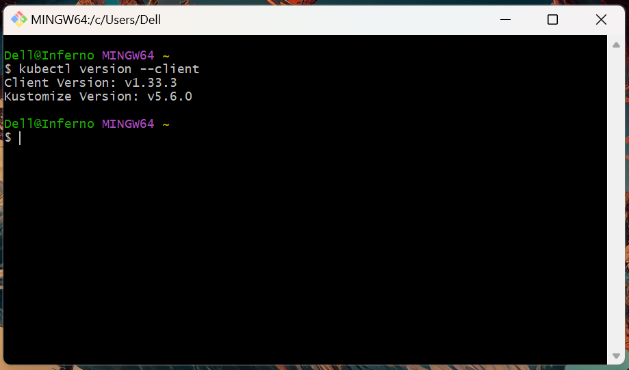

Topics Covered:

1. Established secure authentication with AWS services.

2. Verified installation of core DevOps tools (Terraform, Docker, kubectl, Git).

3. Prepared a reliable baseline environment for all future cloud-native labs.

